Projector to go: Wireless, ultra-compact and bright – Projector
„MobileCinema i70“ with Wi-Fi, battery and stereo speakers now available / direct streaming via Airplay or Miracast
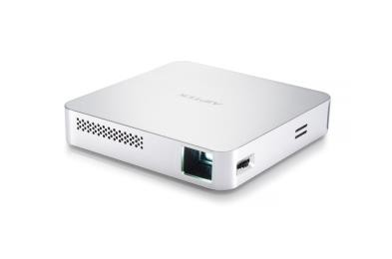
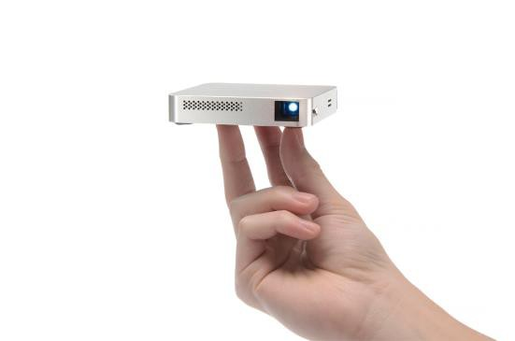
Both on business and holiday trips, the small Wi-Fi projector is the perfect companion for frequent travelers. Due to an integrated battery and Wi-Fi support, it is instantly usable without any cables. Data from iOS- or Android devices are transmitted via Airplay or Miracast to the projector, while other devices can be connected via Wi-Fi and a free app “EZ-Cast” or via mini HDMI.

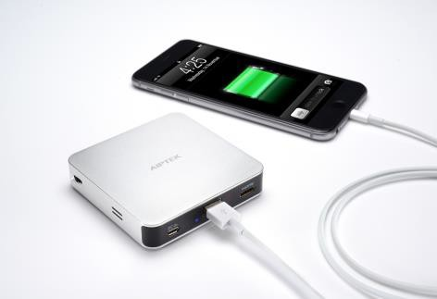
With a weight of only 0.29 lbs and a size of only 3.3 x 3.3 x 0.66 inches (L x W x H), this new gadget fits in every jacket pocket without any problems. Despite the compact dimensions, the DLP projector throws with 70 lumens of brightness a sharp and high-contrast image of up to 80 inch diagonal with a resolution of 854 x 480 pixels on the wall. The sound comes through integrated stereo speakers and the build-in 2.300 mAh battery provides sufficient power without cable clutter. Therefore, the small projector is not only perfect for presentations but also for movie nights via smartphone streaming in hotel rooms or spontaneous image-slideshows at home with friends.

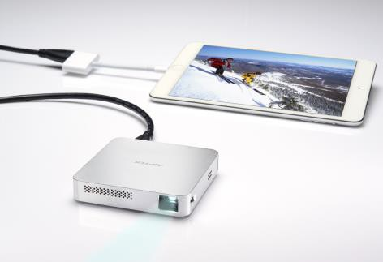
The new Pico-Projector also convinces optically and presents himself in a stylish and stable aluminum design. Furthermore, the energy-saving RGB LEDs offer a lifespan of up to 20.000 hours. The Aiptek „MobileCinema i70“ is on sale now at a SRP of USD 279 and comes with a HDMI cable, USB cable as well as a user manual.

