Public Viewing in the garden: All-in-One projector „Flicks Dashbon“ with 700 lumens of brightness, integrated 3-ways stereo speakers and battery supplies football in a large format and the right sound at your victory celebration party.

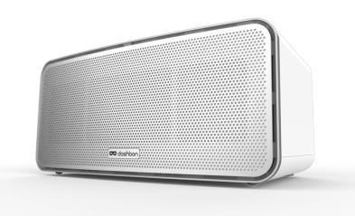
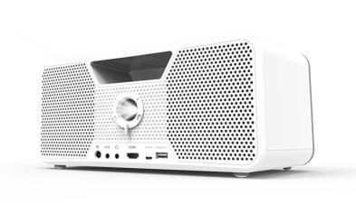
Aiptek brings stadium atmosphere to your home with the new DLP-projector „Flicks Dashbon”. The stylish LED-HD projector in a boombox design, is a flexible party powerhouse. Equipped with a battery and 3-ways stereo speakers with subwoofer, it not only throws a sharp image with up to 120 inch, at a resolution of 1280 x 800 pixels on the wall but also provides excellent sound. In this way the user is completely independent of the technical conditions on-site – both professionally and personally. The image source is connected via HDMI cable to the projector while the right music for your after-game-party can also be streamed via Bluetooth.

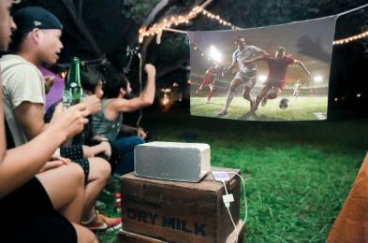
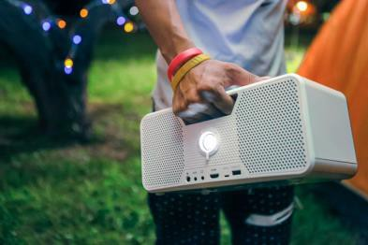
With its dimensions of 299 mm x 166 mm x 135 mm (LxWxH) and a convenient handle, the new projector is both portable and robust. Inside, a powerful DLP chip provides sharp and colorful images, which are brought to the projection surface by energy-saving RGB-LED with a working lifetime of up to 20.000 hours and 700 lumens of brightness as well as a contrast ratio of 10000:1. A vertical keystone correction provides the correct alignment. Mirroring the image for a rear projection is also possible. A missing power source is not a problem at all because under the shiny white surface of the projector, a 13.000 mAh Lithium‐Ion rechargeable battery for up to 4 hours movie playback or 28 hours music via Bluetooth can be found. Optionally, it can also be used as a powerbank via USB to charge your smartphone or tablet.
The „Flicks Dashbon“ is launched on the European market by Aiptek and is available at a price of £599.99, for example on Amazon. The DLP projector comes with a remote control, power supply, HDMI cable and a manual.

